In The Beginning...

Was the Mainframe

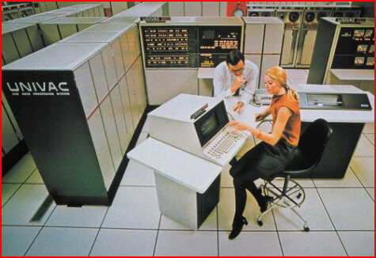

All Data was Unique
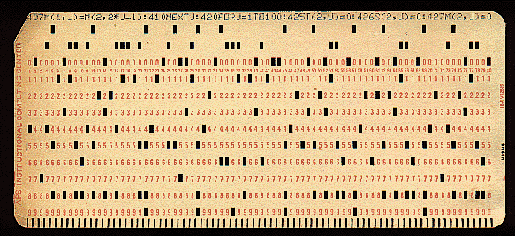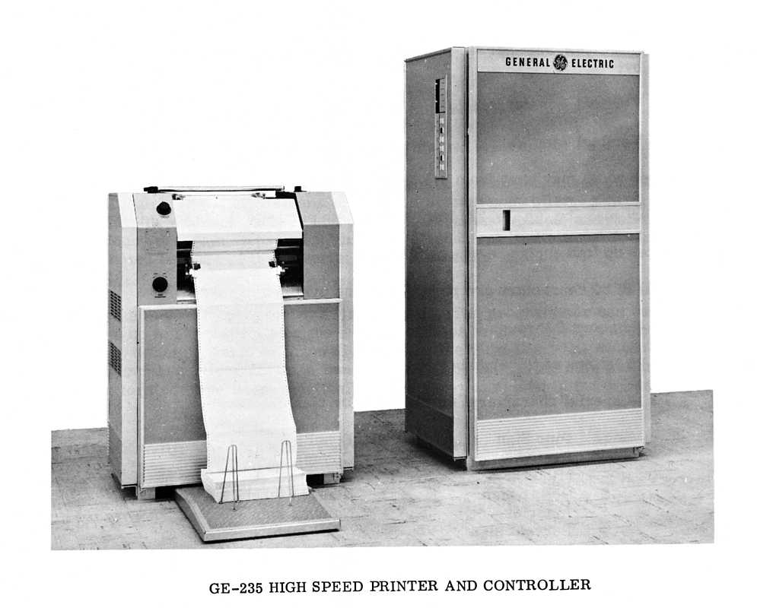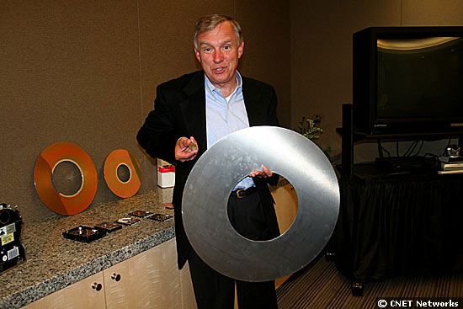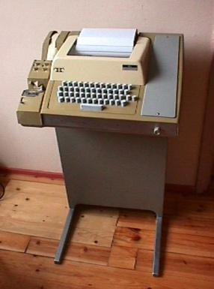
And for each its own Code
//IS198CPY JOB (IS198T30500),'COPY JOB',CLASS=L,MSGCLASS=X
//COPY01 EXEC PGM=IEBGENER
//SYSPRINT DD SYSOUT=*
//SYSUT1 DD DSN=OLDFILE,DISP=SHR
//SYSUT2 DD DSN=NEWFILE,
// DISP=(NEW,CATLG,DELETE),
// SPACE=(CYL,(40,5),RLSE),
// DCB=(LRECL=115,BLKSIZE=1150)
//SYSIN DD DUMMY

And All Was Good ... *


* Well mainly we were too busy typing into the $#!@#@!!! Punch Card Machines and tty’s we didn’t have a spare minute to think of a better way.

Along came some Geeks...
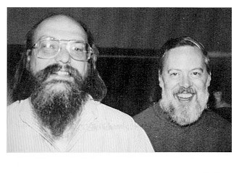
Ken Thompson Dennis Ritchie
“All Data
Should Be The Same !!!”

And so was Born ...
UNIX®


And All Was Good ... *

*Really ! This time I mean it.
®"UNIX is a registered trademark of The Open Group"
Almost 40 years later ...

All data is unique ... again ...
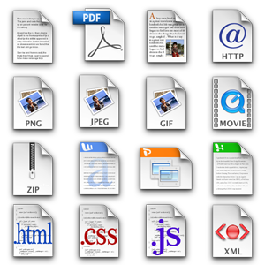

What Would The Ideal
Operating System
Be Like If...

Everything
Was XML

XML Filesystem ?
- Directory structure natively accessed as XML
- IO calls use binary or streaming XML
  - read( int fd , ??? data , int length )
  - write( int fd , ??? data , int length )
    - Infoset ? Binary streaming blobs ?
StAX Events ?
- Every “file” an Infoset Item? Element ?
  - XML Files
    - Binary or Text serialized ?
  - Text files
    - <![CDATA[ ?
    - xs:string() ? ( Infoset item)
  - Binary Files
    - base64 ? yuck.
    - Binary XML CDATA sections ?
  - Devices – ouch !
    - /dev/tty , /dev/sd01 , /dev/lpt
Standard
XML Databases?
- Necessary if we have an XML File system ?
  - Yes !
    - Performance
    - Optimized for special domains
  - No !
    - Make the file system better
- Should come as part of the OS ?
  - Yes !
    - Universally accessible
  - No !
    - Let the market compete
- Should the shell integrate to DB’s ?
  - Yes !
    - Needs a standard interface
  - No !
    - This is what 3rd party tools are for.
Standard XML Tools?

- Traditional UNIX® tools don’t work well with
XML data
  - head tail awk sed grep ed more expr read echo paste cut find cat test ...
- Need new standardized tools for XML
  - xslt xquery xpath xhead xtail xed xls xfind xecho xmore xcat xtest ...
- Traditional UNIX® shells don’t work well with XML data
  - Variables and expressions limited to short strings.
  - Core syntax based on strings and word tokens.
- Need a new shell designed for XML
  - Variables and expressions are XML types
  - Core syntax interoperable with XML
  - XML Pipelines
xmlsh - An XML Shell
- “drop in” replacement for current shells on Unix, Mac, Win32 – any JDK 6 system.
- Direct support for XML data within the shell
  - XML (XQuery) Expressions
  - XML Documents
  - XML Variables
- Core command structure supports XML
for book in <[$doc/BOOK]> ; do
echo Author is <[$book/AUTHOR/string()]>
done
- Standard xml tools and XML pipelines
  - xslt, xpath, xquery, xcat , xsplit , xls , xtest ...
xcat *.xml |
xslt –f style.xsl |
xquery ‘for $x in //item
return <node>{$x/node}</node>’

Come to the presentation!
Wednesday, 11:00 am
What a Great Idea !
What can I do to help?

Are You Nuts?
That’s the dumbest thing I’ve ever heard

